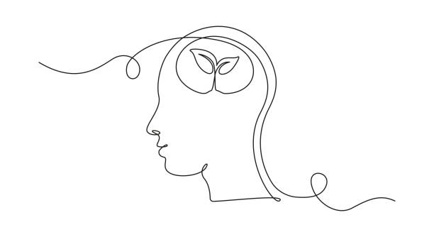

Mental Health Toolkit

5 Steps

1. Identify your coping skills.

*Circle or highlight at least one strategy for each “type” of coping skill:*

|  |  |  |  |
| --- | --- | --- | --- |
| CALMING | DISTRACTING | PHYSICAL | PROCESSING |
| Take a warm or cold bath or shower | Say positive affirmations | Squeeze a stress ball | Talk to a friend, parent, teacher, or counselor |
| Count backwards from 100 to 0 | Watch your favorite movie or TV show | Move your body (go on a walk or a jog, dance, jumping jacks, etc.) | Write a poem, song, or short story |
| Listen to a guided visualization or meditation | Play a game | Rip up paper | Journal |
| Take a nap | Cook or bake | Create something with your hands | Write a letter to someone or to yourself |
| Play with a fidget | Read a book | Pop bubble wrap | Make a list of things you’re grateful for |
| Drink a warm cup of tea | Scribble, doodle, color, or draw | Play with a pet | Make a list of goals you have for yourself |
| Listen to music | Clean your room or organize something (a drawer, your closet, your backpack, etc.) | Give someone a hug | Identify your current feelings and give each one a color |
| Practice deep breathing | Do a crossword or word-search | Stretch and/or yoga | Create a list of things you can control |
| Listen to white noise (sound machine, no-lyric music, ocean sounds, etc.) | Hang out with a friend or family member | Progressive muscle relaxation | Write down negative thoughts and reframe them |

*Add your own unique strategies that are not on this list:*

________________________

__________________________

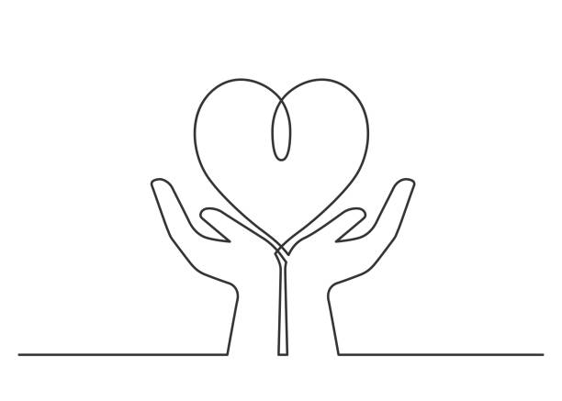________________________

________________________

1. What are your biggest stressors?

*These can change day to day, but in general, what are your most common sources of stress? Identify any specific challenges or situations, and list them here:*

___________________________________________________________________________________

___________________________________________________________________________________

___________________________________________________________________________________

___________________________________________________________________________________

___________________________________________________________________________________

___________________________________________________________________________________

*Now, go back and number your stressors (with “1” being the hardest/most stressful).*

1. Reflect on your daily routine.

*What does your typical day look like after school? Before school? Write down all of your activities here. How much time do you spend doing each?*

___________________________________________________________________________________

___________________________________________________________________________________

___________________________________________________________________________________

___________________________________________________________________________________

___________________________________________________________________________________

___________________________________________________________________________________

*Now, go back and* **⭐***the activities that are most important to you, make you feel good, and/or reduce your anxiety. Put a ☹ next to the things that make you feel bad, increase your stress/anxiety, or waste time (social media scrolling, binging Netflix, engaging in unhealthy behaviors, etc.)*

1. Create a daily self-care plan.

*Daily self check-in questions:*

* *How am I feeling today – mentally and physically?*
* *What’s taking up my headspace right now?*
* *What are some things that I’m feeling stressed or anxious about?*
* *What am I doing to actively manage that stress?*
* *What are some things I might need help with?*
* *Who can help me?*
* *Am I able to identify anything today that may be triggering for my anxiety?*

*List of hobbies, leisure activities, things you like to do for FUN:*

___________________________________________________________________________________

___________________________________________________________________________________

___________________________________________________________________________________

***Set a bedtime goal – remember to allow yourself 7-9 hours of sleep!***

*___:____P.M. = _____ hours of sleep*

***One goal for my physical health today is:***

*Ex: Wash my face in the morning and evening, go on a 15 minute walk after school, take a shower before bed*

___________________________________________________________________________________

___________________________________________________________________________________

***One goal for my mental health today is:***

*Ex: Journal for 15 minutes before bed, take a nap after school, practice one coping skill during school*

___________________________________________________________________________________

___________________________________________________________________________________________

1. Know your support system.

*Using the chart below, list at least 3 additional people that can help you when you are feeling stressed, overwhelmed, dysregulated, etc.*

|  |  |  |  |
| --- | --- | --- | --- |
| NAME | TYPE OF SUPPORT (teacher, parent, counselor, friend, etc.) | WHAT THEY CAN HELP ME WITH | HOW TO CONTACT/ACCESS THEM |
| Ms. Smith | School Counselor | Anything! Academic, social/emotional, peer conflict, future planning, etc. | Counseling office, appointment scheduler Google Form, or email -  cnsmith@olatheschools.org |
| Mrs. Rodden | School Counselor | Anything! Academic, social/emotional, peer conflict, future planning, etc. | Counseling office, appointment scheduler Google Form, or email -  cnsmith@olatheschools.org |
|  |  |  |  |
|  |  |  |  |
|  |  |  |  |
|  |  |  |  |

**“Only when we are brave enough to explore the darkness**

**will we discover the infinite power of our light.”**

**- Brené Brown**