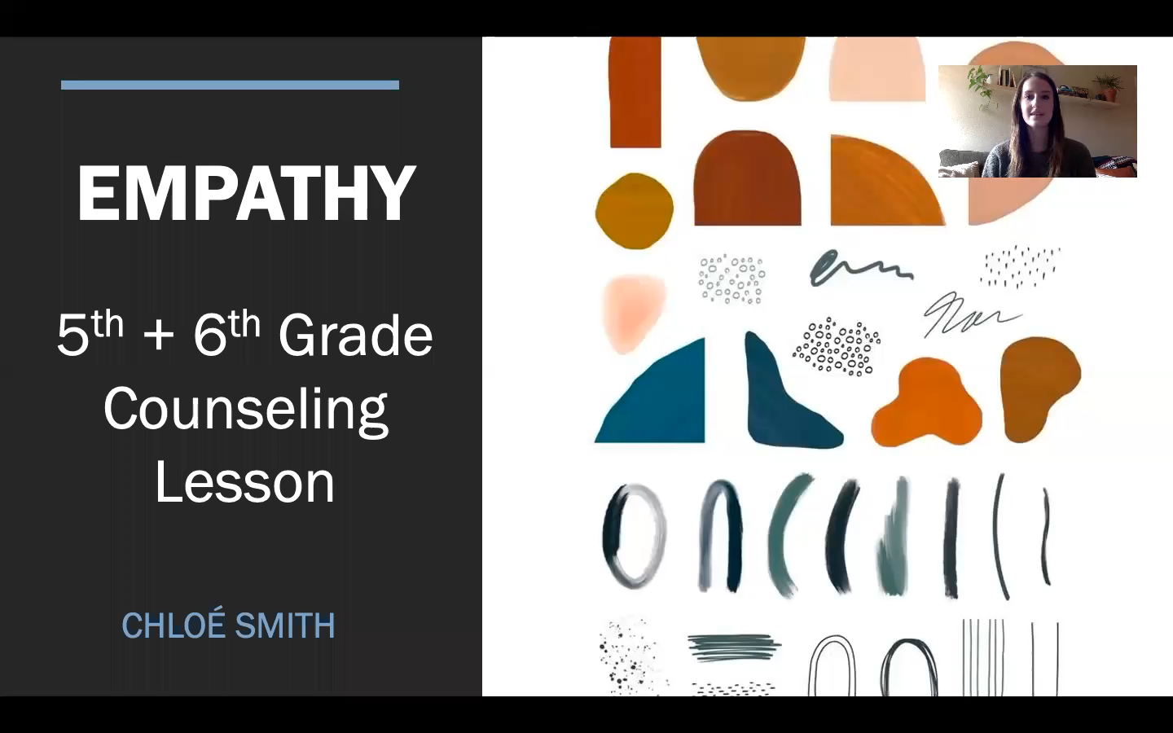

**GRADES:** 5-6

**THEME:** Empathy

**DATE:** April 14, 2021

**STANDARDS:**

KSDE:SE:S1.B1.2, SE:S1.B1.3 (KSDE, 2015)

ASCA:B-SS 4 (ASCA, 2019)

**MATERIALS:**

* Human scavenger hunt worksheet (one per student)
* Blank piece of “printer” paper (one per student)
* Writing utensils (one per student)
* Computer + access to YouTube
* Projector

**ANTICIPATORY SET/INTRODUCTION OF NEW MATERIAL:**

* Have students sit on the floor as the counselor projects Brené Brown’s *empathy vs sympathy* video on the screen
  + <https://www.youtube.com/watch?v=1Evwgu369Jw&t=57s>
* Counselor will define empathy for the class
* Counselor presents question to the class: “How did the bear handle the situation differently than the antelope?”

**ACTIVITY:**

* The counselor will give the students a “human scavenger hunt” that has a list of scenarios on it.
* The students will be asked to get into pairs (or groups of three depending on class size).
* The counselor will read the first scenario out loud to the class.
* The students will be asked to share with their partner (or group) what they would feel if they were in that scenario, taking notes on their worksheet of what their partner shared.
* Repeat forementioned process for all four scenarios, choosing a different partner for each scenario.
* The counselor will then direct students back to their desks.
* The counselor will ask students to share some of the feelings they wrote down that their partners had shared.
* The counselor will lead a brief class discussion on how/why those feelings match with the scenarios at hand.

**CLASS DISCUSSION:**

* The counselor will have prepared four hypothetical situations – two that DO describe empathy and two that do NOT describe empathy.
* As the counselor reads the scenarios individually, the students will be asked to either show a “thumbs up” if the scenario does display empathy or a “thumbs down” if the scenario does not display empathy.

**EVALUATION:**

* Students will be given a blank sheet of “printer paper” that they will be asked to fold in half twice (creating four squares on the page).
* The counselor will present a situation to the class: “My mom made spaghetti for dinner, and I hate spaghetti, so I told my mom that I wasn’t going to eat it.”
* The counselor will have the students write, on the paper sectioned into four, what they may feel in that moment, what their mom may feel in that moment, what a sibling might feel in that moment, what your stomach might feel in that moment.
* Have students share/discuss their answers with the person they’re sitting next to.

***“When you go home, ask the adult you live with what they would feel in certain situations, and it may surprise you how differently they may feel than you would in certain scenarios!”***

**ESTIMATED TIME:** 30-minute lesson

**SOURCES:**

Education.com (Ed.). (2007). Empathy Scenarios. Retrieved April 14, 2021, from <https://www.education.com/download/worksheet/174518/empathy-scenarios.pdf>

TheRSAorg (Director). (2013, December 10). *Brené Brown on empathy* [Video file]. Retrieved April 15, 2021, from https://www.youtube.com/watch?v=1Evwgu369Jw&t=57s